|  |  |  |  |
| --- | --- | --- | --- |
|  |  |  |  |

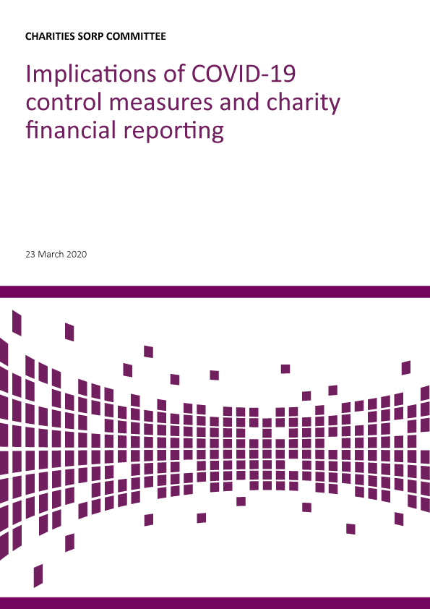

**Status of this advice**

Due to the exceptional current circumstances, the SORP-making body is issuing advice on the financial reporting implications that may arise from the measures being put in place to contain the impact of the COVID-19 virus.

This advice does not amend the SORP, is advisory in nature and aims to assist preparers, auditors and examiners of accounts. There is no obligation to apply this advice. Relevant paragraphs of the SORP are noted where appropriate.

**Effective:** any accounts which have not yet been approved.

**Brief summary**

These are unprecedented times and the situation is changing rapidly for individuals and organisations. The key messages from our advice here are:

* The measures being taken to contain COVID 19 will impact on charities in many different ways and it is important for charity trustees to understand the impact on the delivery of their activity and their governance including their finances.
* Where a charity is preparing a set of accounts and these have not yet been approved, trustees should consider whether information needs to be included to explain the impact of the COVID 19 situation on their charity.
* There could be changes to the financial statements needed as a result of the COVID 19 situation and it is important that trustees understand and consider these.
* Charities should keep up to date with developing guidance from the relevant charity regulator in their jurisdiction.

**The implications of COVID 19 related control measures**

The measures being taken by Governments in the UK and Ireland are intended to limit the harm to individuals from the virus and preserve healthcare capacity for the severely ill. For more information on these measures refer to the Government website in your charity law jurisdiction.

The measures involve a high degree of social disruption which has an impact on the delivery of and demand for the activities of charities, the availability of staff for work, and levels of illness across society which will affect the beneficiaries of charities. There are therefore potential implications for charity income, expenditure and commitments, and the value of charity assets and liabilities. In some cases the implications may be so severe as to cast doubt upon a charity’s financial sustainability.

**Trustees’ Annual Report including risk reporting**

Trustees will need to consider the impact on the financial statements as a result of the changing activities of the charity itself. These could relate to:

* fundraising
* the changing circumstances of staff and volunteers
* changes not controlled by the charity such as the demand for charitable services, the effect of failing supply chains and the value of the charities’ assets and liabilities due to changes to the economy including fixed assets, pensions assets and liabilities and investments.

Trustees will also be aware that it will be important to provide users of the accounts with information about the material decisions they have had to take on judgements and uncertainties.

When preparing their trustees’ annual report, charity trustees may wish to consider:

* In reporting the main achievements of the charity (paragraph 1.20) explaining how the virus control measures affected the charity’s activities
* Taking the opportunity to explain any financial uncertainties regarding the charity’s financial sustainability and consideration of going concern (paragraph 1.23) and the steps being taken to address these uncertainties
* Explaining how the contribution of volunteers, where appropriate, assisted the charity in its work in managing in the changed circumstances (paragraph 1.39)
* The impact on the charity’s ability to fundraise (paragraph 1.41) and how the trustees managed this situation
* How the outbreak of the virus has affected staff, volunteers and beneficiaries and the implications for the charity’s operations and activities for the coming year (paragraph 1.45)
* How the financial and operational effects of the virus and the control measures relating to the virus affected the principal risks and uncertainties facing the charity during the reporting period (paragraph 1.46)
* Give consideration whether there are any implications for any existing or potential defined benefit pension liability (paragraph 1.47) and investments the charity holds (paragraph 1.47)
* Consider any impact on the charity’s reserves policy, level of reserves and any change to designated funds set aside for future commitments (paragraph 1.48)
* Consider the likely impact of the virus control measures and potential duration of the control measures on the future aims and activities of the charity (paragraph 1.49)
* The impact of the virus related control measures on any wider network of which the charity is a part and how this affects the charity’s operations (paragraph 1.51)

**Accounting related considerations**

**‘True and Fair’-** the trustees when preparing and/or approving the charity’s accounts are responsible for ensuring that the accounts give a true and fair view. This is based on an assessment that the reported income, expenditure, assets, liabilities and funds are fairly described and stated as at the reporting date (financial year-end), taking into consideration all relevant information regarding the conditions existing as at the reporting date. In the current circumstances this may mean that the accounts are not prepared on a going concern basis but on an alternate basis.

**Post balance sheet events -** trustees must ensure that changes are made for adjusting events. Adjusting events are those events occurring after the end of the reporting period but before the accounts are approved which provide evidence of conditions existing at the reporting date that affect items in the balance sheet and items reported in the statement of financial activities. (see module 13 of the SORP).

Examples of adjusting events may include recognition of impairment losses or adjustments to impairment losses where trustees are in receipt of information after the end of the reporting period indicating that an asset was impaired or that the impairment loss itself needs adjusting.

In particular, consideration will be needed as to whether economic disruption means that the value of debtors or stock for resale may be overstated or that the likely impact of the virus on the charity’s principal sources of income means that the charity may not be a going concern.

Post balance sheet events only need to be adjusted for where there is evidence of conditions existing at the reporting date. For example, as the COVID-19 crisis developed in 2020, it will be the case that December 2019 year end accounts are far less likely to be subject of an adjusting event.

Trustees will also need to consider including disclosures on non-adjusting balance sheet events (see paragraph 13.7). The disclosure of non-adjusting events provides useful and relevant information about the charity to users of the accounts. Examples of non-adjusting events might be:

* a material loss in the value of an assets subsequent to the reporting date.
* a material loss in the value of investments

**Going concern considerations -** when assessing their charity’s ability to continue to adopt the going concern basis of accounting, trustees should consider all available information about the future at the date they approve the accounts. In particular giving consideration to information from budgets and forecasts for income, expenditure and cash-flows. Attention should be given to the available unrestricted funds and reserves, credit facilities (such as overdrafts), and any other forms of financial assistance available to the charity.

The assessment of going concern is a forward looking assessment (paragraphs 3.14 and 3.38). In this regard the FRC issued guidance for company directors in 2016 regarding their assessment of going concern may also be of assistance to trustees: ‘Guidance on the going concern basis of accounting and reporting on solvency and liquidity risks’

**Alternate basis for accounts preparation where not a going concern -** if the accounts cannot be prepared on a going concern basis this is disclosed (paragraph 3.38). Consideration should then be given to the effect on the accounting policies (SORP module 3), in particular judgments and estimates to do with the valuation on assets and liabilities including any known liabilities resulting from any decision to wind the charity up. The decision to wind up the charity is not a pre-requisite for not preparing accounts on a going concern basis because in deciding as to whether the accounts are prepared on a going concern the trustees will have had to make judgments as to the future financial circumstances facing their charity; provided continued operations would not amount to wrongful trading then the trustees may decide to continue to operate after the reporting date.

Where accounts are not prepared on a going concern basis then assets may be valued on the basis of the values that they are expected to be recoverable and/or realised on disposal. Liabilities may be valued on the basis of the likely value when crystallised. The trustees are advised to disclose any significant assumptions made as to the nature of disposal and its impact on valuations of assets and the judgments as to the market or disposal values assigned. Consideration should be given to any impairment with respect to operational and other assets (SORP module 12).

**Defined benefit pension liabilities -** the valuation of pension assets and liabilities may be affected by changes in financial markets for shares and other securities and government bonds. Trustees may wish to contact the trustees of any defined benefit pension schemes in which their employees are members or for which there are ongoing obligations to identify any potential implications for the charity going forward. Unless any change to conditions as at the reporting date results from this information then it would not be an adjusting event (SORP module 13).

**Liabilities and provisions -** charities providing goods and services to beneficiaries may need to give consideration as to any costs arising from potential or actual disruption to supply chains, availability of staff, and the charity’s ability to fulfil any contractual obligations or meet performance targets which may give rise to additional costs or penalties. Unless any change to conditions as at the reporting date results from this information then it would not be an adjusting event (SORP module 13).

**Audit and external scrutiny**

Trustees need to consider the impact of control measures on the ability of the charity to prepare its report and accounts and on the availability of the audit team or independent examiner to undertake their review. Allowance will need to be made for alternative means of verifying matters and providing evidence which may involve the trustees in additional effort or require more time to complete.

**Reporting to the charity regulator by charity trustees**

Trustees should consider whether there is a matter to do with beneficiary welfare or the charity’s ability to continue which they may need to notify to their charity regulator. Reference should be made to the website of the relevant charity regulator for further guidance.

**Filing and going concern, trustees’ filing responsibilities and late filing**

A disagreement as to the going concern status of their charity between the trustees and their auditor or independent examiner is not a reason for non-submission of the accounts. Once the auditor has given their opinion or the independent examiner has made their report then filing is made with the registrar.

If the circumstances facing the trustees are such that the trustees’ annual report and accounts (or Directors’ annual report and accounts) will be filed late then reference should be made to the respective charity regulator(s) and, where appropriate Companies House (UK) or the Companies Registration Office (Republic of Ireland) for more information as to the implications of late filing.

