CHARITIES SORP (FRS 102)

Accounting and Reporting by Charities: Statement of Recommended Practice applicable to charities preparing their accounts in accordance with the Financial Reporting Standard applicable in the UK and Republic of Ireland (Second Edition)

INFORMATION SHEET 6: Irish Charities - Merger Accounting and Republic of Ireland Company Law

Publication date: 15 June 2020

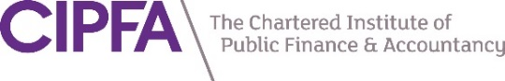

Secretariat to the joint SORP-making body:

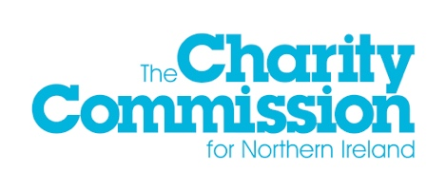
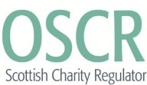

Background

The Charity Commission for England and Wales (CCEW), the Charity Commission for Northern Ireland (CCNI), and the Office of the Scottish Charity Regulator (OSCR) comprise the joint SORP-making body for charities and as such are required by the Financial Reporting Council (FRC), in accordance with its Policy on Developing Statements of Recommended Practice (SORPs), to keep the Statement of Recommended Practice (SORP) under review.

As part of this work, the joint SORP-making body may issue information sheets which seek to clarify the application of the SORP or particular recommendations contained within the SORP. Information sheets may also cover matters not addressed in either FRC standards or the SORP, but which are relevant to charity reporting and on which the joint SORP-making body considers additional guidance to be necessary. Information sheets do not amend the SORP, are advisory in nature and are released to assist preparers, auditors and examiners of accounts.

It should be noted that information sheets do not form part of the SORP, nor are they reviewed by the FRC and therefore they do not carry the authority of the SORP. They do not introduce new standards for the preparation of financial statements or impose particular interpretations of statutory prescriptions or recommendations of the SORP.

References to reporting standards are correct at the date of publication. Where this information sheet predates changes to accounting standards and a conflict is thereby created, or other developments lead to a conflict, the affected clarifications offered in this information sheet cease to have effect.

Context

Update Bulletin 1 amended the Charities SORP (FRS 102) to confirm that due to changes in UK company law, charities that are UK registered companies and enter into a business combination with a third party will no longer be able to apply merger accounting to that combination. This position has also been confirmed in paragraph 27.4A of the Charities SORP (FRS 102) (second edition). This Information Sheet advises that the same position exists in company law in the Republic of Ireland.

All reasonable care has been exercised in preparing this information sheet. However, it is important for preparers of accounts to make reference both to the relevant SORP modules and to FRS 102 when preparing accounts, presenting the financial statements and in making the required disclosures.

1. Introduction and background

Purpose of Information Sheet

  - The purpose of this information sheet is to clarify the position in relation to Republic of Ireland company law with respect to paragraph 27.4A of the Charities SORP (FRS 102) (second edition).

  - The Charities SORP (FRS 102) (second edition) includes the following at paragraph 27.4A:

Due to changes in UK company law, charities that are UK registered companies and enter into a business combination with a third party will no longer be able to apply merger accounting to that combination. Unincorporated charities, charitable incorporated organisations and non-UK registered companies will continue to be able to apply merger accounting if they meet the criteria set out in FRS 102 and this SORP and merger accounting is not prohibited by other relevant legislation. The joint SORP-making body will issue an information sheet to confirm the position for Irish charitable companies. If a charitable company is considering a true and fair override in order to use merger accounting it is encouraged to read Appendix III Note on Legal Requirements of FRS 102 and if adopting merger accounting to provide the corresponding disclosures.

Extract from Charities SORP (FRS 102) (second edition)

  - This information sheet provides the clarification referred to in paragraph 27.4A.

Impact

  - The Charities SORP (FRS 102) (second edition) provides guidance for charities in the Republic of Ireland on how to apply FRS 102. Update Bulletin 1 issued in February 2016 confirmed that due to changes in UK company law, charities that are UK registered companies and enter into a business combination with a third party, will no longer be able to apply merger accounting to that combination.

  - This Information Sheet advises that the prohibition of merger accounting described in paragraph 27.4A of the Charities SORP (FRS 102) (second edition) applies equally to charitable companies operating under Republic of Ireland company law. Irish charitable companies will therefore no longer be able to apply merger accounting where they enter into a business combination with a third party. The change to Republic of Ireland company law will apply to financial years commencing on or after 1 January 2017.

  - Organisations will be able to continue to apply merger accounting if they meet the criteria set out in FRS 102 and the Charities SORP (FRS 102) (second edition) and merger accounting is not prohibited by other relevant legislation, these include:

    - unincorporated charities;

    - charitable incorporated organisations;

    - entities (including ones structured as charitable companies) which are based outside the UK and the Republic of Ireland and subject to legal frameworks which do not prohibit merger accounting, and which are entering into an entity combination with a charity or charitable subsidiary which prepares its financial statements in accordance with FRS 102 and the Charities SORP.

  - Paragraph 27.4A makes mention of Appendix III Note on Legal Requirements of FRS 102. Republic of Ireland company law references corresponding to UK company law references in Appendix III, can be found in Appendix IV of FRS 102 Republic of Ireland legal references.

